**Assignment 3**

By Harsh Sharma

***Part I***

**Question 1**. Suppose that the data mining task is to cluster the following eight data points with two attributes into three clusters, where the data points are:

p1(2, 10), p2 (2, 5), p3(8, 4), p4 (5, 8), p5(7, 5), p6(6, 4), p7(1, 2), p8(4, 9)

Here we name each data point with p1, p2, p3, etc. for convenience.

**Solution:**

1. The K-means algorithm steps are as follows:

Step 1: Initialize the centroids.

Step 2: Assign each data point to the nearest centroid.

Step 3: Update the centroids based on the assigned data points.

Step 4: Repeat steps 2 and 3 until convergence (when the centroids no longer change significantly).

Therefore, calculating **Euclidean** distances for each iteration:

**Iteration 1**

Step 1: We have the following centroids as per the question: (2,10), (5,8), and (1,2).

Step 2: Assign data points to the nearest centroid. We calculate the Euclidean distance between each data point and the centroids and assign each point to the nearest centroid.

The clustering as per nearest Euclidean distance:

Cluster 1 (Centroid: (2,10)): p1(2,10)

Cluster 2 (Centroid: (5,8)): p4(5,8), p5(7,5), p6(6,4), p8(4,9), p3(8,4)

Cluster 3 (Centroid: (1,2)): p2(2,5), p7(1,2)

Step 3: We update the centroids by calculating the mean of the data points assigned to each centroid.

Updated centroids:

New Centroid for Cluster 1: ((2)/1, (10)/1) = (2, 10)

New Centroid for Cluster 2: ((5+7+6+4+8)/5, (8+5+4+9+4)/5) = (30/5, 30/5) = (6, 6)

New Centroid for Cluster 3: ((2+1)/2, (5+2)/2) = (1.5, 3.5)

**Iteration 2**

Step 2: Intermediate Clustering based upon new centroids:

Cluster 1 (Centroid: (2,10)): p1(2,10), p8(4,9)

Cluster 2 (Centroid: (6,6)): p4(5,8), p5(7,5), p6(6,4), p3(8,4)

Cluster 3 (Centroid: (1.5,3.5)): p2(2,5), p7(1,2)

Step 3: Update Centroids:

New Centroid for Cluster 1: ((2+4)/2, (10+9)/2) = (3, 9.5)

New Centroid for Cluster 2: ((5+7+6+8)/4, (8+5+4+4)/) = (26/4, 21/4) = (6.5, 5.25)

New Centroid for Cluster 3: ((2+1)/2, (5+2)/2) = (1.5, 3.5)

**Iteration 3:**

Compute the Euclidean distance between each data point and the centroids. Assign each data point to the cluster whose centroid is the closest.

Step 2: New Clustering

Cluster 1 (Centroid: (2,10)): p1(2,10), p8(4,9), p4(5,8)

Cluster 2 (Centroid: (6,6)): p5(7,5), p6(6,4) , p3(8,4)

Cluster 3 (Centroid: (1.5,3.5)): p2(2,5), p7(1,2)

Step 3: Update Centroids

New Centroid for Cluster 1: ((2+4+5)/3, (10+9+8)/3) = (3.6, 9)

New Centroid for Cluster 2: ((7+6+8)/3, (5+4+4)/3) = (21/3, 13/3) = (7, 4.3)

New Centroid for Cluster 3: ((2+1)/2, (5+2)/2) = (3/2, 7/2) = (1.5, 3.5)

**Iteration 4**

Step 2: Assign points to new centroids.

Cluster 1 (Centroid: (3.6, 9)): p1(2,10), p8(4,9), p4(5,8)

Cluster 2 (Centroid: (7, 4.3)): p5(7,5), p6(6,4) , p3(8,4)

Cluster 3 (Centroid: (1.5,3.5)): p2(2,5), p7(1,2)

Step 3: Update centroids

Recalculate the centroids of the clusters based on the current member data points.

New Centroid for Cluster 1: ((2+4+5)/3, (10+9+8)/3) = (3.6, 9)

New Centroid for Cluster 2: ((7+6+8)/3, (5+4+4)/3) = (21/3, 13/3) = (7, 4.3)

New Centroid for Cluster 3: ((2+1)/2, (5+2)/2) = (3/2, 7/2) = (1.5, 3.5)

The clusters do not change in the intermediate step 3. Hence, we have reached convergence after Iteration 4.

Final Clustering Result:

Cluster 1 (Centroid: (3.6, 9)): p1(2,10), p8(4,9), p4(5,8)

Cluster 2 (Centroid: (7, 4.3)): p5(7,5), p6(6,4) , p3(8,4)

Cluster 3 (Centroid: (1.5,3.5)): p2(2,5), p7(1,2)

Final Centroids:

Centroid 1: (3.6, 9)

Centroid 2: (7, 4.3)

Centroid 3: (1.5, 3.5)

Final results after convergence:

|  |  |  |
| --- | --- | --- |
| **(3.6, 9)** | **(7, 4.3)** | **(1.5, 3.5)** |
| P1 | P5 | P2 |
| P8 | P6 | P7 |
| P4 | P3 |  |

1. Computing SSE (Sum of Squared Error): To compute SSE, we calculate the squared distance between each data point and its respective centroid and sum them up for each cluster.

Cluster 1 SSE:

Distance to Centroid 1 = sqrt((2 - 3.6)^2 + (10 - 9)^2) ≈ 1.8867

Distance to Centroid 1 = sqrt((4 - 3.6)^2 + (9 - 9)^2) = 0.4

Distance to Centroid 1 = sqrt((5 - 3.6)^2 + (8 - 9)^2) ≈ 1.7204

SSE Cluster 1 = (1.8867)^2 + (0.4)^2 + (1.7204)^2 ≈ 6.68

Cluster 2 SSE:

Distance to Centroid 2 = sqrt((7 - 7)^2 + (5 - 4.3)^2) ≈ 0.7

Distance to Centroid 2 = sqrt((6 - 7)^2 + (4 - 4.3)^2) ≈ 1.044

Distance to Centroid 2 = sqrt((8 - 7)^2 + (4 - 4.3)^2) ≈ 1.044

SSE Cluster 2 = (0.7)^2 + (1.044)^2 + (1.044)^2 ≈ 2.67

Cluster 3 SSE:

Distance to Centroid 3 = sqrt((2 - 1.5)^2 + (5 - 3.5)^2) ≈ 1.58

Distance to Centroid 3 = sqrt((1 - 1.5)^2 + (2 - 3.5)^2) ≈ 1.58

SSE Cluster 3 = (1.58)^2 + (1.58)^2 ≈ 5

Step 2: Calculate the total SSE:

Total SSE = SSE Cluster 1 + SSE Cluster 2 + SSE Cluster 3

Total SSE ≈ 6.68 + 2.67 + 5 ≈ 14.35

**Question 2:** The table below is a proximity matrix with the similarity values of all pairs of data points p1, p2, p3, p4, and p5. Note that the matrix shows similarity values, not distance (dissimilarity) values.

Solution:

To perform single-link agglomerative hierarchical clustering using the given similarity matrix, we'll follow these steps:

Step 1: Initialize each data point as a separate cluster.

We start with five clusters: p1, p2, p3, p4, and p5.

Step 2: Find the pair of clusters with the highest similarity.

Looking at the similarity matrix, the highest similarity value is 0.98 between p2 and p5.

Step 3: Merge the two most similar clusters into a single cluster.

We merge clusters p2 and p5 into a new cluster.

Step 4: Update the similarity matrix.

To update the similarity matrix, we need to compute the similarity between the new cluster and the remaining clusters.

**Updated similarity matrix:**

p1 p3 p4 p2,p5

p1 1.00 0.41 0.55 0.35

p3 0.41 1.00 0.44 0.85

p4 0.55 0.44 1.00 0.76

p2,p5 0.35 0.85 0.76 1.00

Step 2: Find the pair of clusters with the highest similarity.

The highest similarity value is 0.85 between p3 and the merged cluster p2,p5.

Step 3: Merge the two most similar clusters into a single cluster.

We merge clusters p3 and p2,p5 into a new cluster.

Step 4: Update the similarity matrix.

Updated similarity matrix:

p1 p4 p3,p2,p5

p1 1.00 0.55 0.35

p4 0.55 1.00 0.76

p3,p2,p5 0.35 0.76 1.00

**Iteration 2**

Step 2: Find the pair of clusters with the highest similarity.

The highest similarity value is 0.76 between p4 and the merged cluster p3,p2,p5.

Step 3: Merge the two most similar clusters into a single cluster.

We merge clusters p4 and p3,p2,p5 into a new cluster.

Step 4: Update the similarity matrix.

Updated similarity matrix:

p1 p3,p2,p5,p4

p1 1.00 0.35

p3,p2,p5,p4 0.35 1.00

**Iteration 3**

Step 2: Find the pair of clusters with the highest similarity.

The only remaining similarity value is 0.35 between p1 and the merged cluster p3,p2,p5,p4.

Step 3: Merge the two most similar clusters into a single cluster.

We merge clusters p1 and p3,p2,p5,p4 into a new cluster. Now, all the data points are in a single cluster.

Step 6: Create the dendrogram.

((((p2, p5),p3),p4),p1)

The dendrogram visually represents the clustering process, showing the order in which the points are merged.

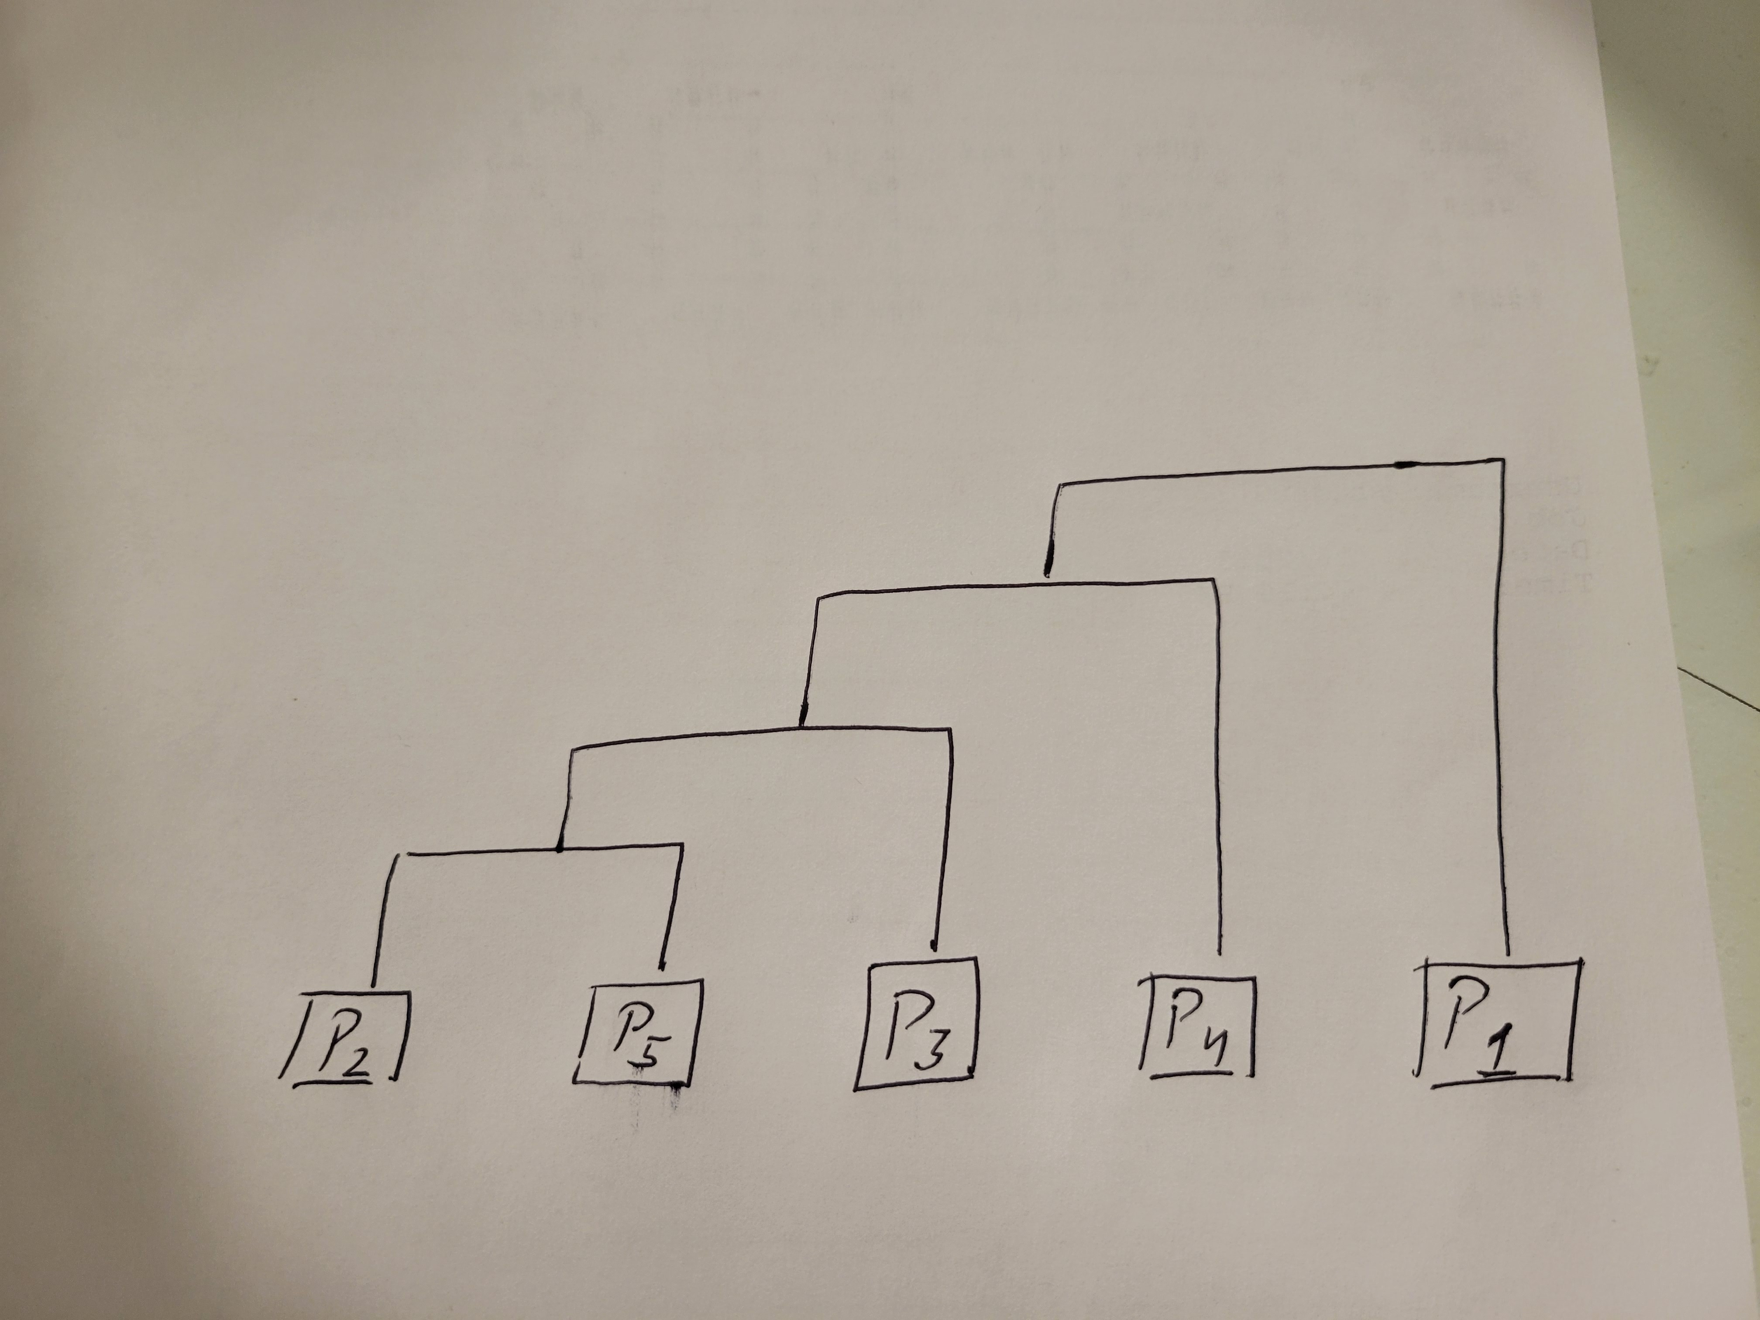

The dendrogram shows that p2 and p5 are merged first, followed by p3 joining the cluster. Finally, p4 is merged with the existing cluster, resulting in all data points (p1, p2, p3, p4, p5) being in the same cluster at the end.

**Question 3.** The figure below shows a two-dimensional data set. Suppose we perform a density-based clustering with the data set, assuming that we use the Euclidean distance between points, and that = 2 and = 3.

**Solution:**

Since the minimum points inside a core point has to be 3, we can safely remove the following points: p, v, a, x, l, m, u, o, p.

Since these points don’t have three points within the maximum distance of 2, given by epsilon in the question. And so we now need to calculate only on the rest of the points.

Now in order to calculate the Euclidean distance we need to find the coordinates of all the points. The coordinates are:

a = (5, 8) b = (10, 8) c = (11, 8) d = (6, 7) e = (10, 7) f = (12, 7) g = (13, 7) h = (5, 6) i = (10, 6) j = (13, 6) k = (6, 5) l = (9, 4) m = (11, 5) n = (14, 6) o = (15, 5) p = (2, 4) q = (3, 4) r = (5, 4) s = (6, 4) t = (7, 4) u = (15, 4) v = (3, 3) w = (7, 3) x = (8, 2)

Now we find the Euclidean Distance between each point to find the core points.

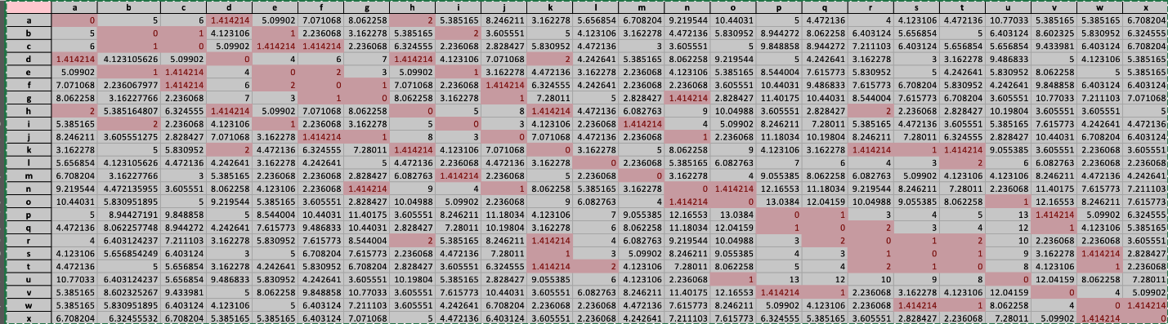

According to questions we have following parameter to find core points.

Minimum Points = 3, and Epsilon = 2.

This means that me need to have a minimum of 3 points inside the radius of 2, (epsilon). Using the following filtering criteria we get following core points: b, c, d, e, f, g, h, I, j, k, q, r, s, t, w

Total Core points: #15

They are: b, c, d, e, f, g, h, I, j, k, q, r, s, t, w

Total Noise points: #9

They are: p, v, a, x, l, m, u, o, p

***Part II***

P1. **The purpose of this practice is to get familiar with R scripts for clustering analysis. Follow “Ch 9. Clustering” tutorial from Zhao, “R and Data Mining”. The tutorial document is attached. Submit:**

* 1. **Your program codes, e.g., the R script codes in the tutorial document**
  2. **A proof to show the successful execution of your codes, e.g., screen shots on running, and the output. Alternatively, you can show the same results using Python or any other programming language you prefer.**

**Solution:** The screenshot below demonstrates the implementation of problems discussed in chapter 6.

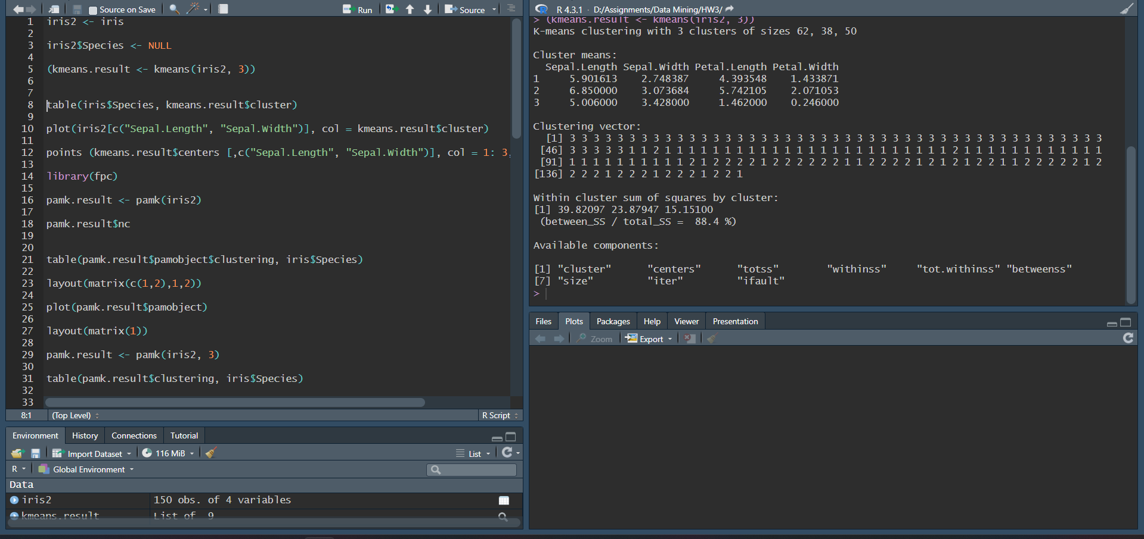

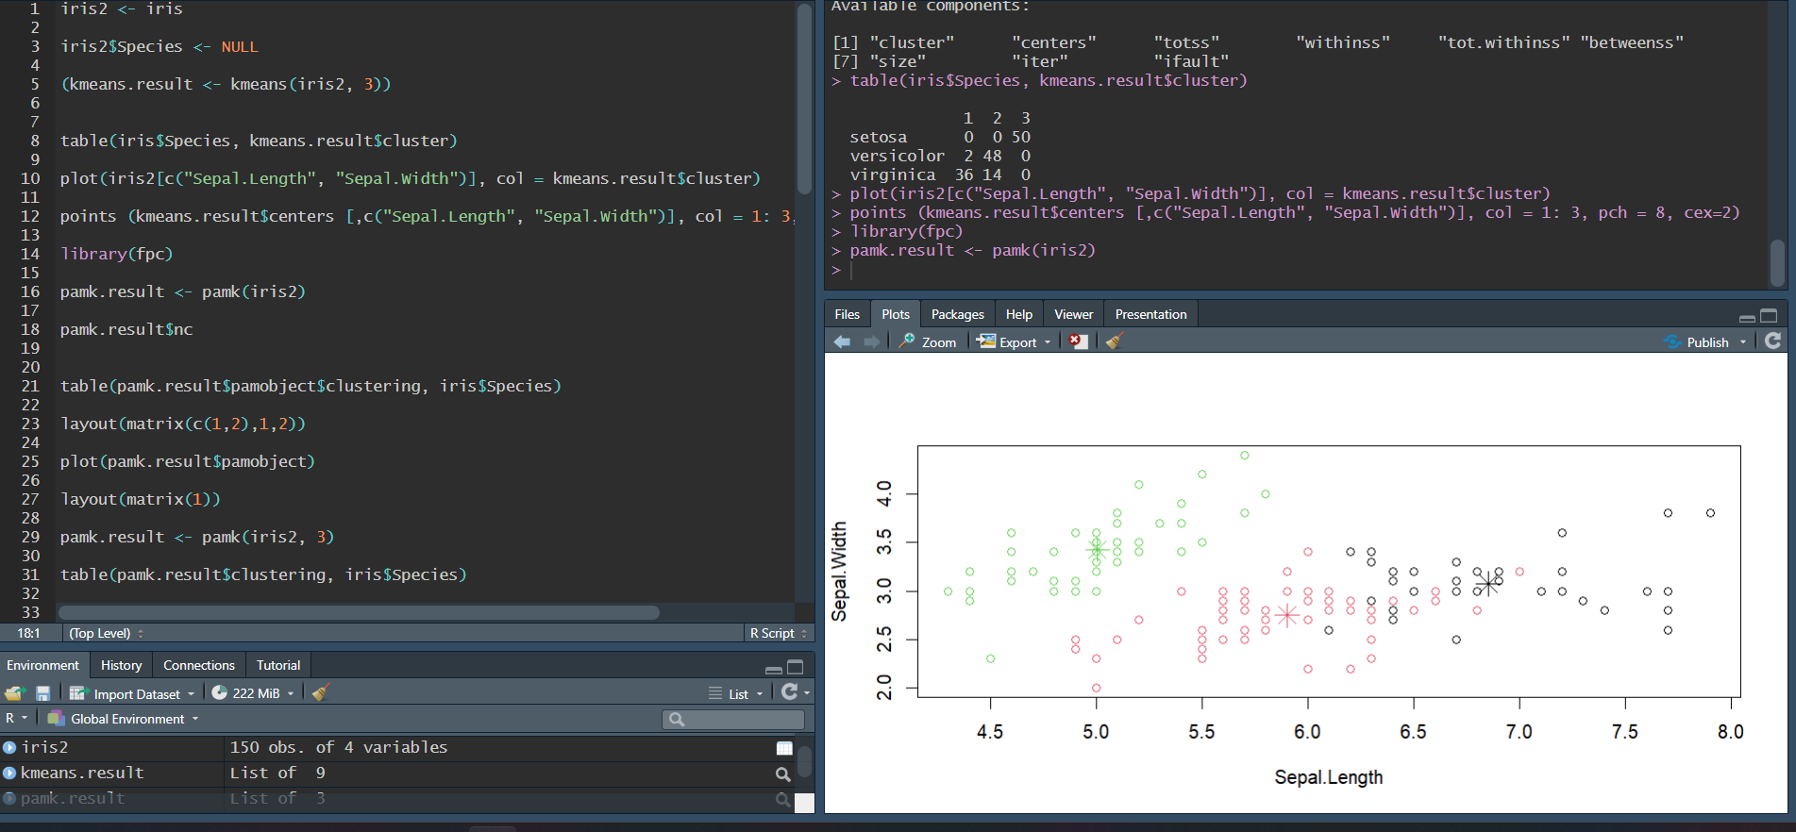

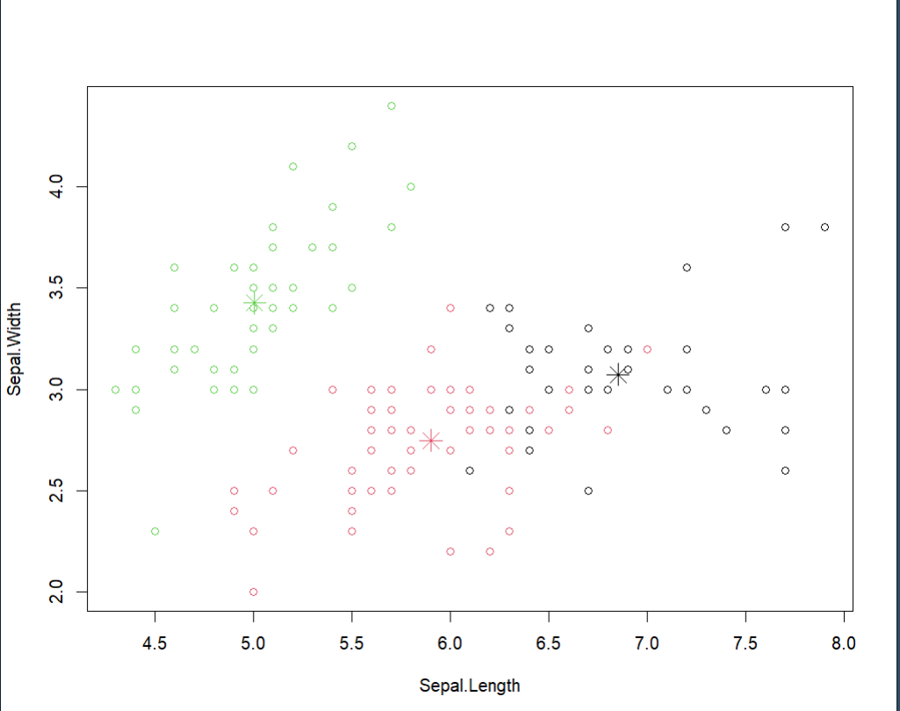

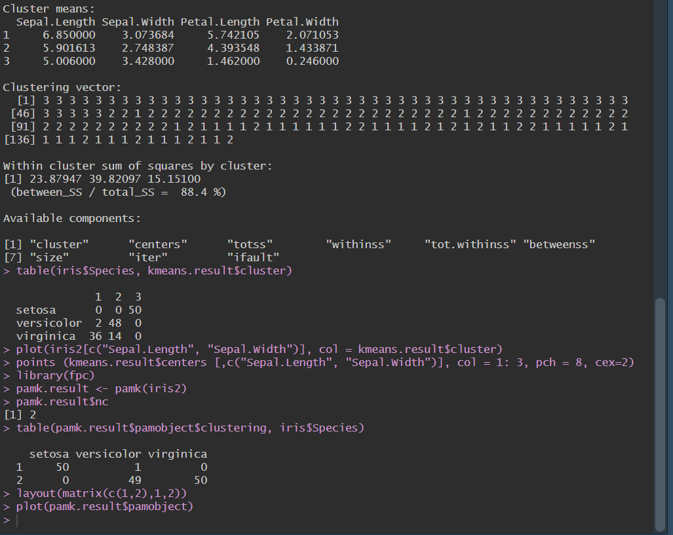

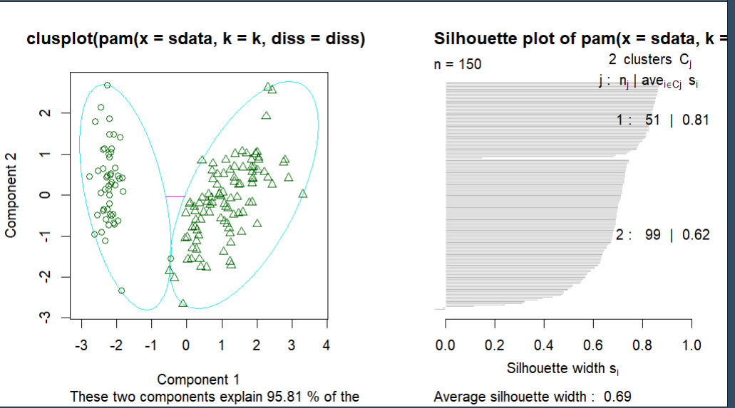

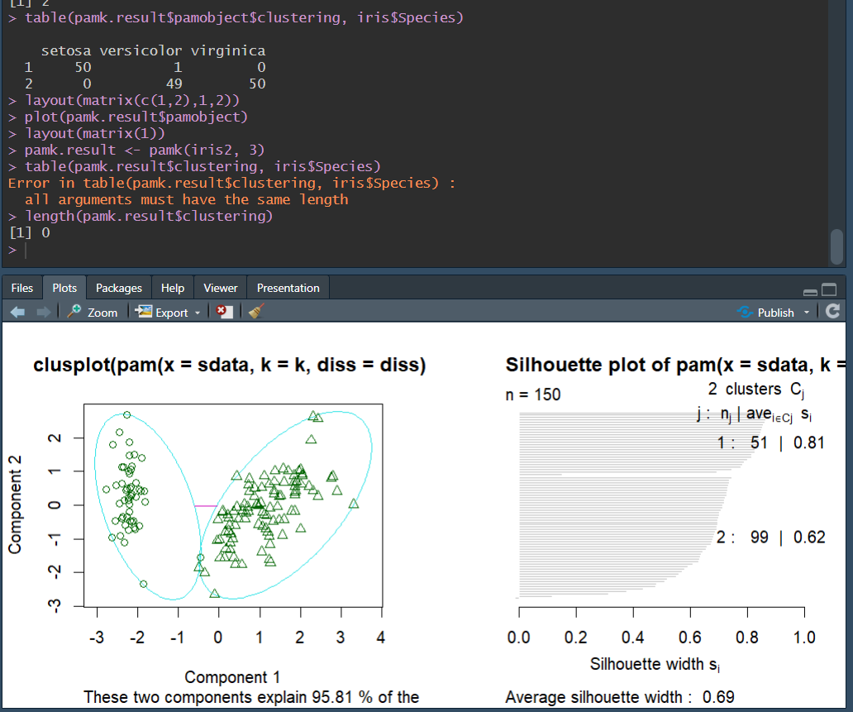

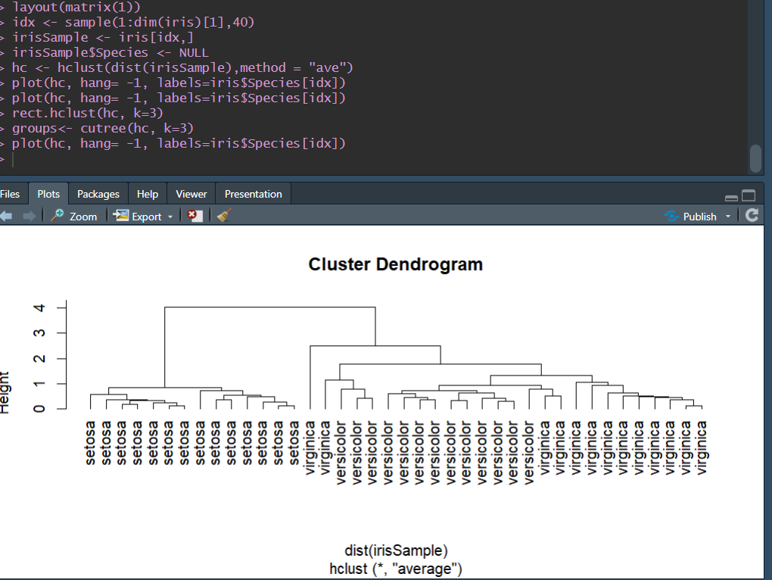

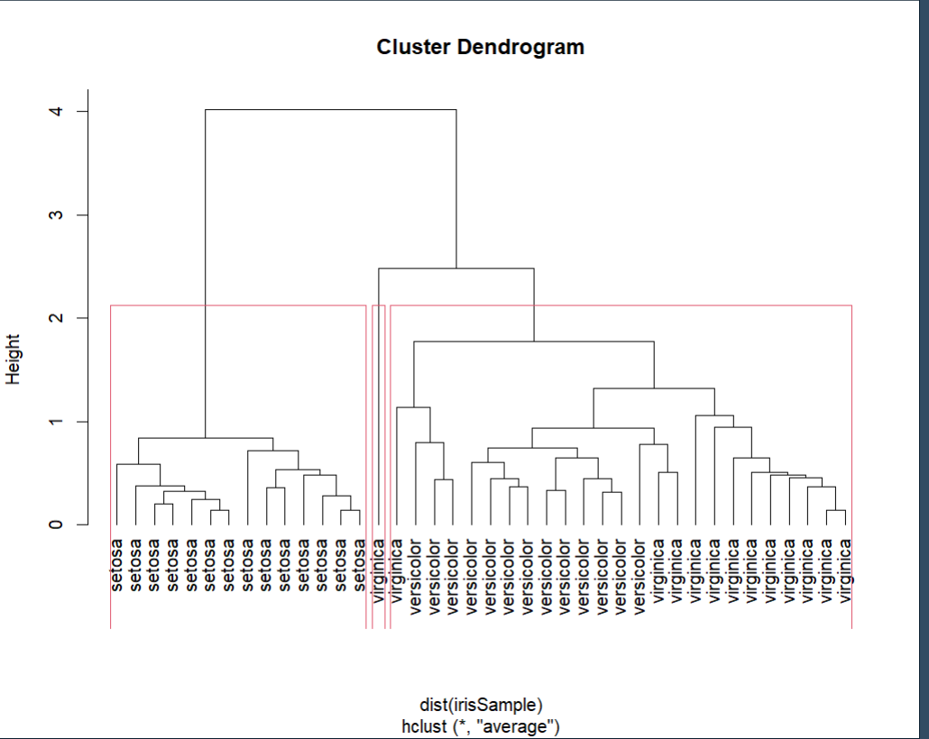

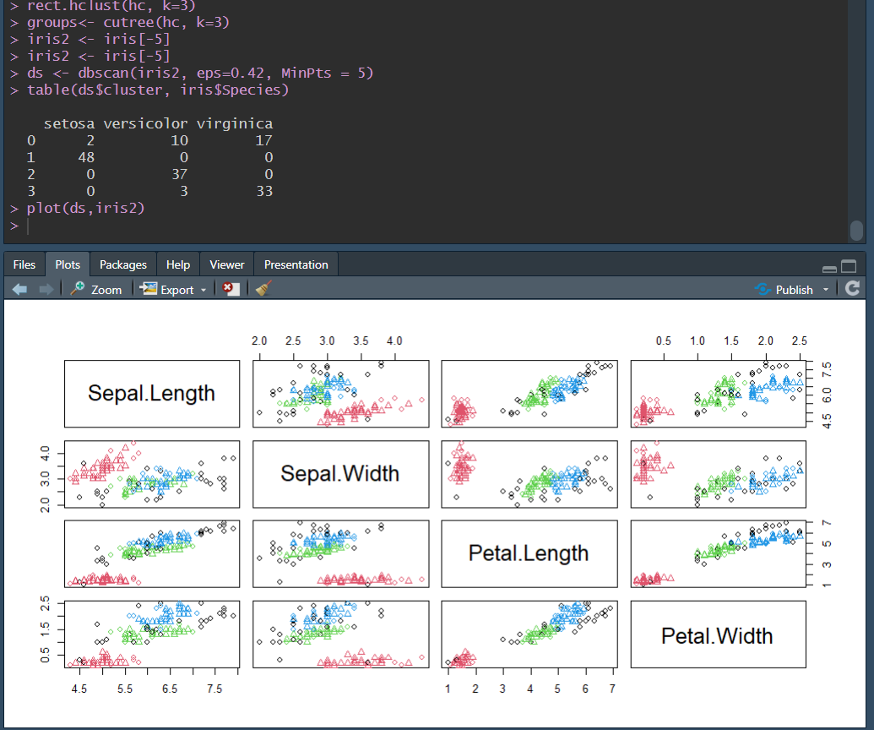

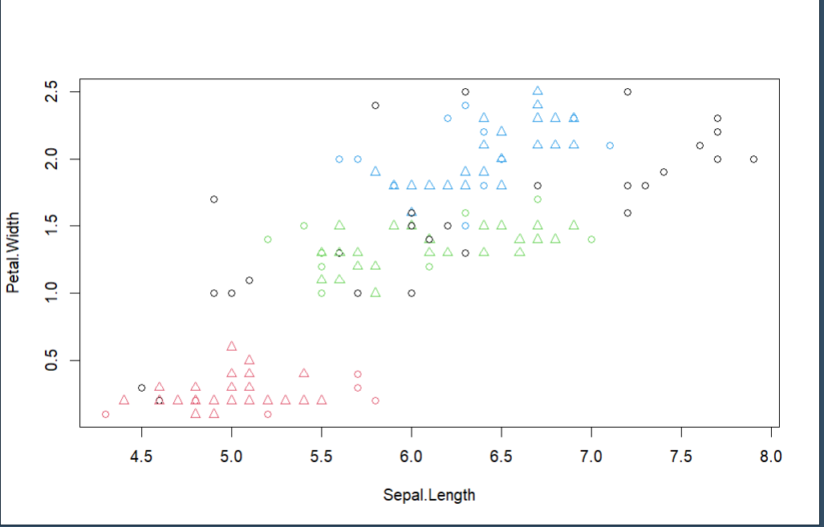

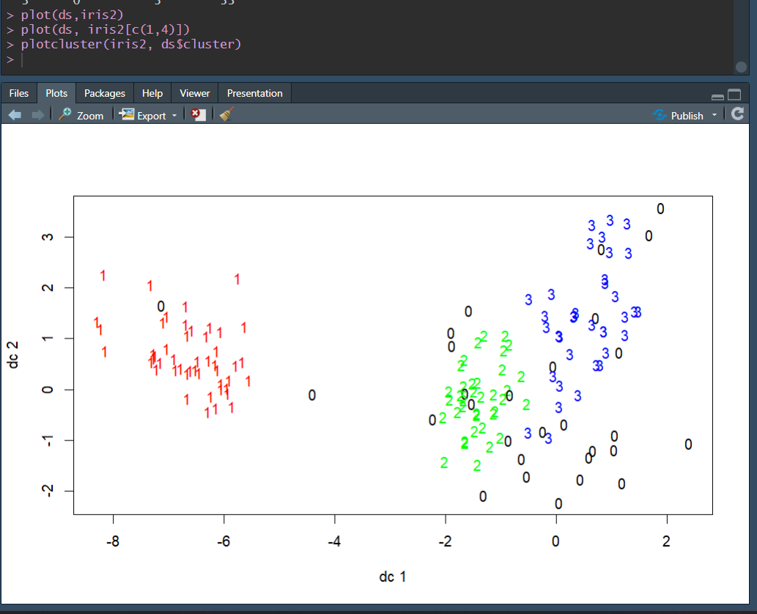

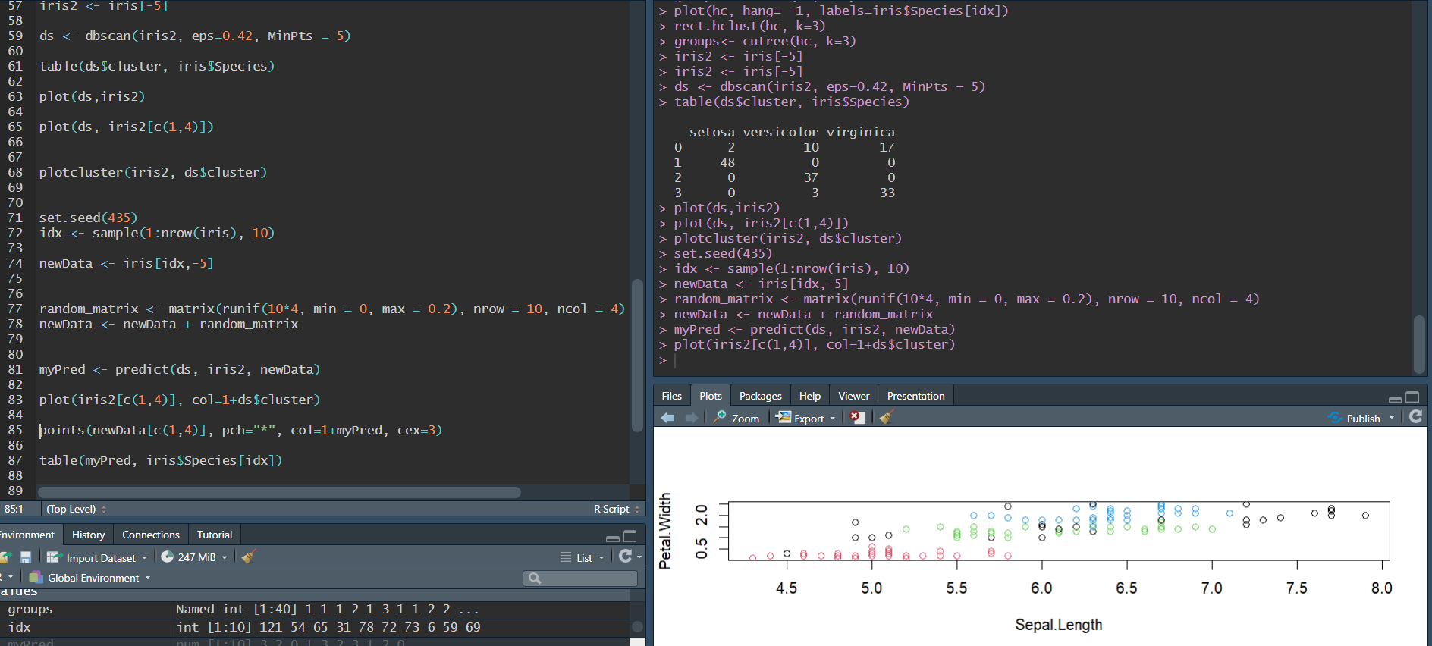

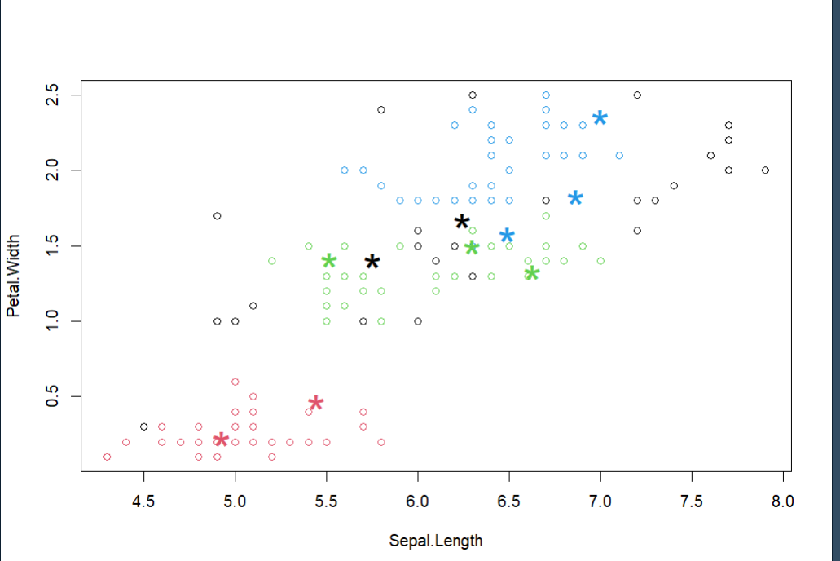

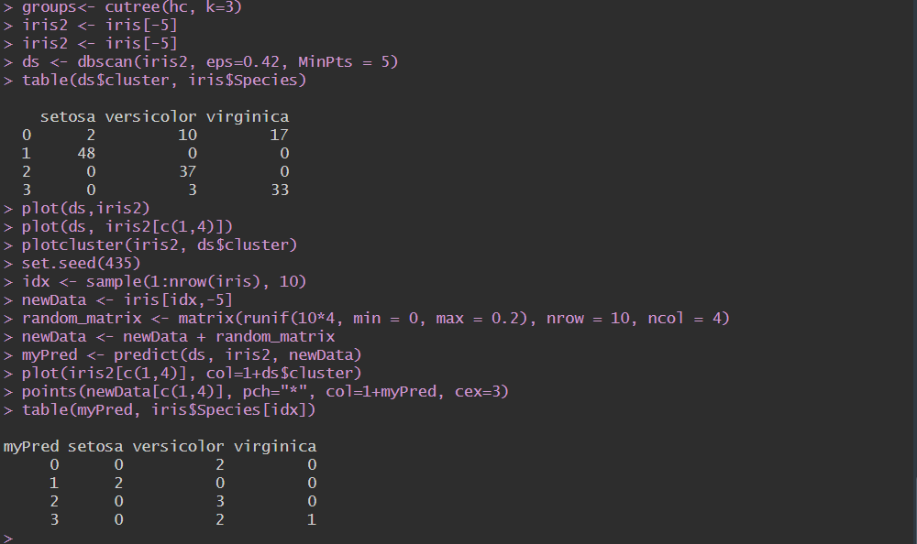

P2. For the following tasks, you can use any programming language (R, Python, etc.) and APIs or a data

mining tool.

(1) (Data Preparation and Data Transformation) The dataset has 8 attributes. Two attributes, CHANNEL and REGION, are nominal, and the others are continuous. For this study, we will use only numeric attributes except CHANNEL and REGION. The numerical attributes show different magnitude of values. To bring all the attributes to the same magnitude, standardize the attributes. Prepare a data file (named trans_data.csv) with these attribute values.

Solution:

I’ve used python to normalize the values and the code is being shared in the file: ‘**normalised.py’** And the normalized result is stored in the file**: ‘trans_data.csv’**

Here is the screenshot to showcase the normalized values. Both the files are attached to assignment.

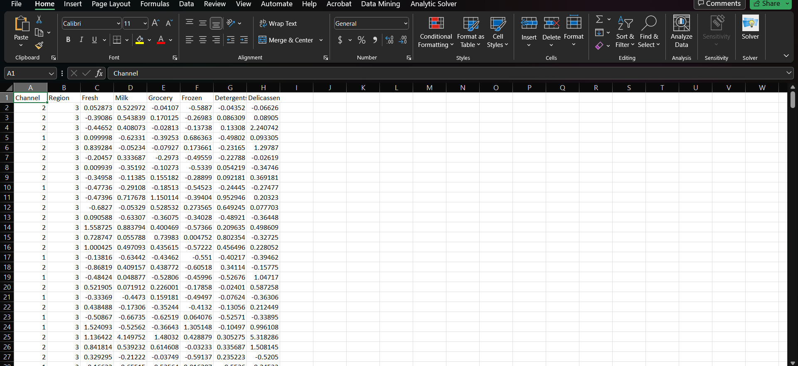

(2) (Cluster tendency) Compute the Hopkins statistics of the trans_data. Determine whether the warehouse customer data shows useful clustering tendencies using the Hopkins statistics value.

Solution:

I’ve used python to calculate Hopkins statistics value and the code is being shared in the file: ‘**hopskins.py’** For this particular dataset, the final Hopkins statistics value is 0.9999999349885561

Here is the screenshot of result and code:

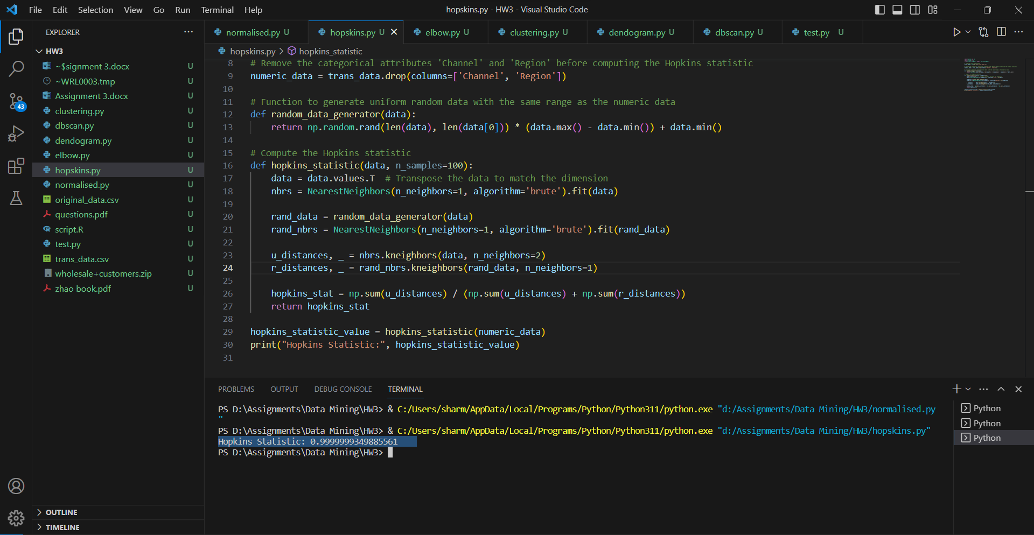

(3) (Optimal number of clusters) Before the actual clustering, identify the optimal number of clusters (k)

for the data with the trans_data data using Elbow method or Shilhouette method. Write an optimal number of clusters you found. Briefly explain it.

Solution: I’ve used Elbow method to calculate the optimal number of clusters.

**According to my analysis, the number of optimal clusters is 8.**

**Explanation**: When I took the maximum number of clusters to be just 5, I got a straight declining line with no turning/elbow point.

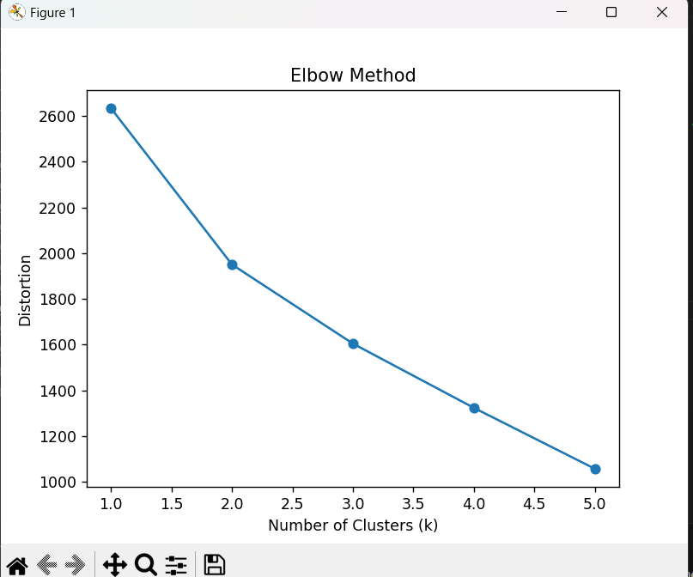

For max clusters to be 10, this is the graph:

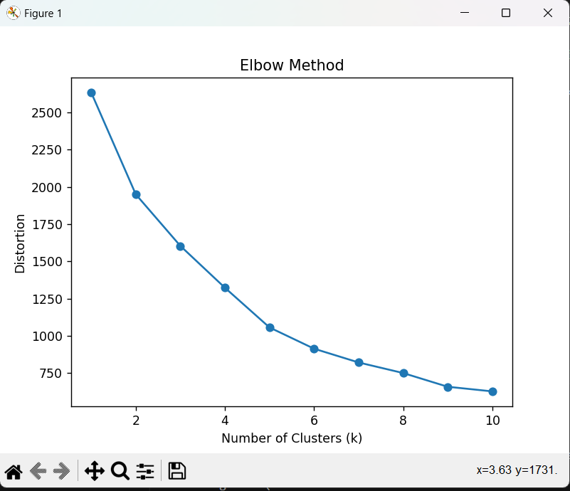

There seems to be a turning point/elbow point around 8. After k=8, the graph tends to flatten out a little bit. (one can also argue that the graph flattens after k=9. It’s personal preference.)

To verify that 8 is the optimal solution, I also tested for max clusters to be 100.

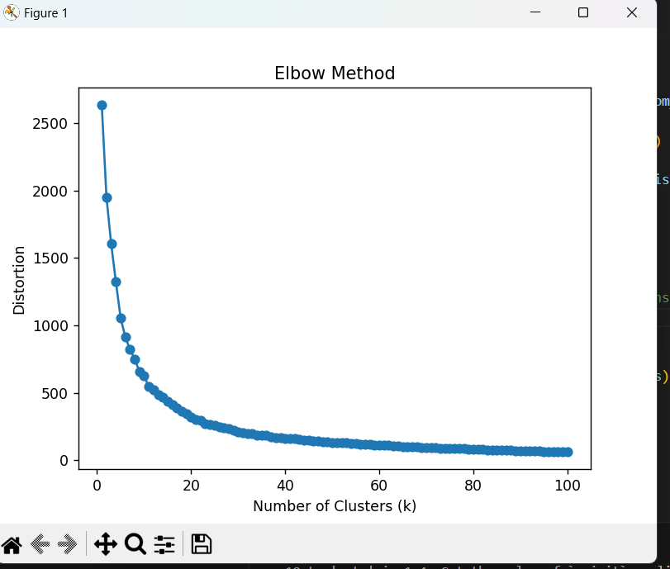

Again, it verifies our previous decision as after around k=8, the graph tends to flatten out. Therefore the optimal numbers of cluster for this dataset is 8.

The code is available in this python file: ‘**elbow.py**’

P3. For the following tasks, you can use any programming language (R, Python, etc.) and APIs or a data

mining tool.

(1) (Representative-based clustering) Perform the cluster analysis using k-means with k=6. For the input

data, use the trans_data data from P2 (2). Report the clustering result. For that, you may prepare a result file (named k-means-result.csv) which is similar with the input data file but includes the name of cluster (e.g., Cluster1) a data point belongs to.

**Solution:** The solution is stored in a python file: ‘**clustering.py**’ and the data is stored in csv file**: ‘k-means-result.csv’**

Here is the screenshot of the result:

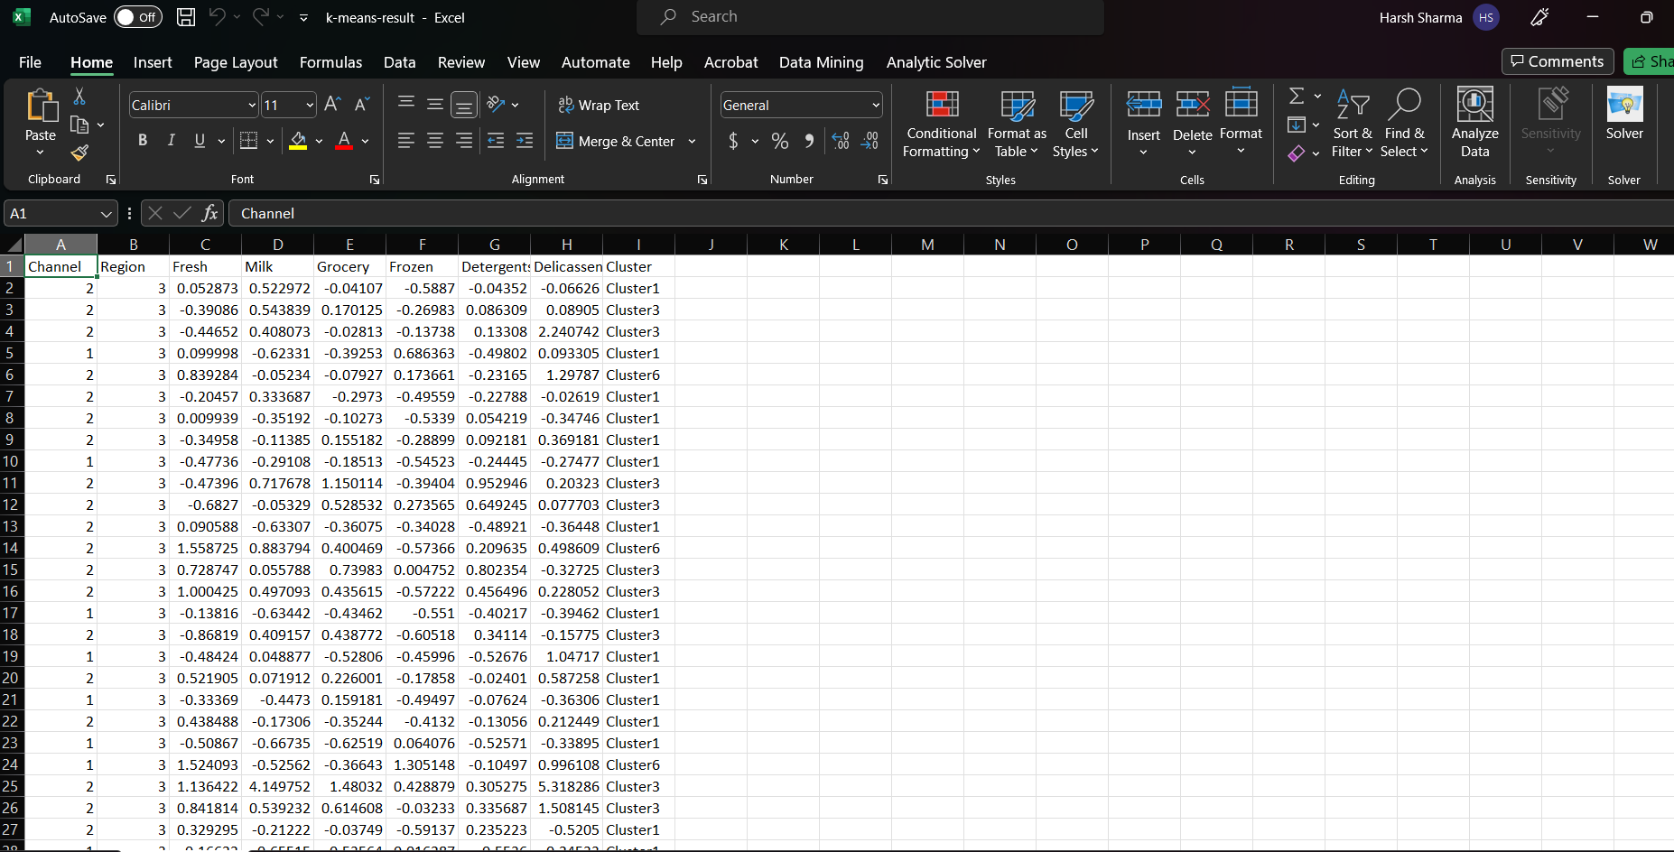

(2) (Hierarchal clustering) Perform the cluster analysis using a complete link agglomerative hierarchical clustering algorithm. For the input data, use the trans_data data. Show the dendogram for the clustering result.

**Solution:** The solution is stored in a python file: ‘**dendogram.py**’ Here is the screenshot of the result:

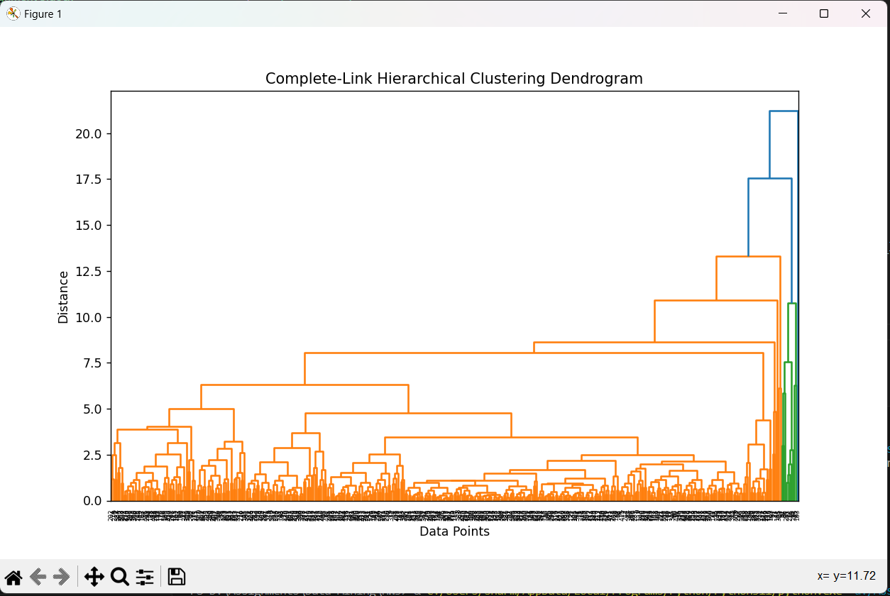

(3) (Density-based clustering) Perform the cluster analysis using DBSCAN with = 0.5 and = 15. For the input data, use the trans_data data. Show the clustering result. For that, you may prepare a result file (named DBSCAN-result.csv) which is similar with the input data file but includes the name of cluster a data point belongs to.

**Solution:** The solution is stored in a python file: ‘**dbscan.py**’ and the data is stored in csv file**: ‘DBSCAN-result.csv’**

Here is the screenshot of the result:



